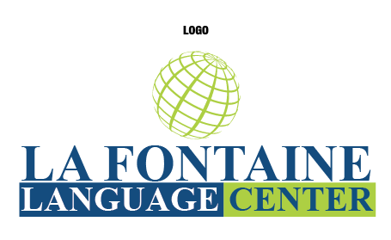
REGISTRATION FORM
La Fontaine Language Center, LLC
Tel: 404-218-2402
www.lafontainelanguages.net
regina@lafontainelanguages.net

Course___________

Registration fee: $50 (USD)
Monthly Payment: $400 (USD)

Payments must be received before class. Class materials will be delivered to you in class.

Please make payments in class or on the website at www.lafontainelanguages.net. Also, you may send registration form by email at regina@lafontainelanguages.net.

Please fill out information below:

Name __________________________________________________________

Cell Phone ______________________________________

Address_______________________________________________________________________________________

City _____________________________State ____________ Zip code ___________________

Email:________________________________________________________________________________________

REFUND POLICY

Due to our flexible schedules and our competitive prices, it is not possible to give you a refund after the date you register.
Group classes may not be canceled or rescheduled.
If my check is returned my account may be electronically debited for the full face value and any applicable fees
I am aware of the Language Center policies and I am registering for the above classes

Signature _________________________________ Registration Date _____________

